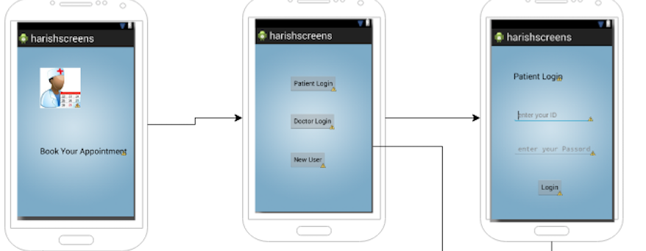

Step 1: -  
There is a flash screen in the starting when you open an app, representing a doctor icon and saying

BOOK AN APPOINTMENT.  
Then the second screen will pop up.

Step 2: - In the second screen we can see three button   
Patient login, Doctor login, and new user.  
for each button you press it navigates to the next screen, now we are talking about patient login button, when you press the button it navigates to another scree which displays Patients User id and Password to enter.  
  
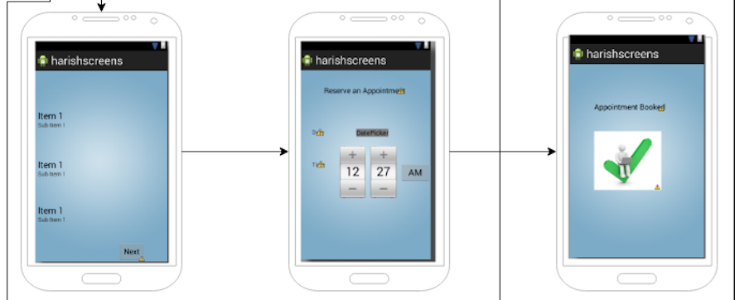

Step 3: - Once you enter the password and id of a patient it then navigates to next screen which displays and presents the tabs of booking appointment with a doctor, like date, time, patient information once you are done with all this it shows that Appointment is booked.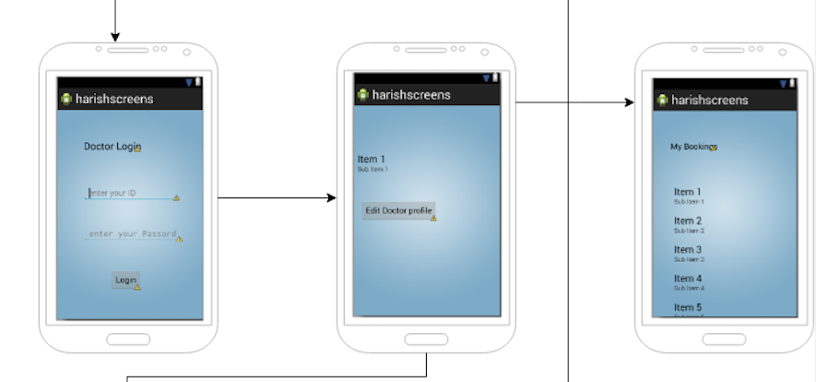

Step 4: -

Now consider the previous main screen in which there all the three buttons which leads us to the login of the users,  
pressing a Doctor login button navigates to a screen in which doctor ID and Password will be displayed to enter, once you enter all the details , then another screen will be pop up in which User(Doctor) can view the patients information, booking, time, reason for the appointment.  
A button EDDIT PROFILE is present if you enter or press it Doctor (user) can edit his profile, change his timing etc.

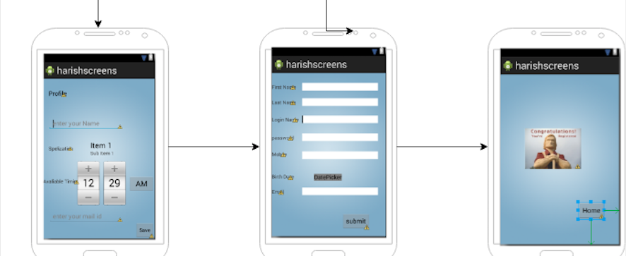

Step 5: - The button New User navigates to a new screen, In which a new user can create or setup an id and password asking the user to enter name, number, address, and small information of a new user,  
once you are done entering all the details then your ID, and Password is ready to use.  
This is how the Application works, and a brief explanation of each and every screen wit navigation towards next screen.